**APPLICATION FOR NEW FIXED HARDWARE ROUTE**

|  |  |
| --- | --- |
| **APPLICANT INFORMATION** | |
| **Applicant Name(s)** |  |
| **Phone Number** |  |
| **Email Address** |  |
| **Recommended Route Name** |  |
| **Rock Formation** |  |
| **Number of bolts to be placed** |  |
| **Type of hardware to be used** |  |

Bolt Placement Information:

* Stainless steel bolts are required.
* Minimum bolt size shall be 1/2” x 2 3/4”.
* Bolts and hangers must be camouflaged prior to inserting into the rock.
* Cold shuts are prohibited.
* Drive-in bolts are prohibited.
* Motorized rock drills are recommended.
* Only chains and/or links are permitted as anchors, no cord or webbing.
* When replacing fixed hardware, the holder will make every effort to repair and restore the rock to its natural state.
* FCC will make every effort to notify OSMP if sensitive wildlife species (bats, raptors, or other rare species) are observed during route reconnaissance or route installation.

Applications **must** include the following images to be reviewed by OSMP staff. Images may be uploaded or pasted directly into this application document.

* A photo or diagram of the rock formation with the proposed route drawn in
* A photo or diagram of the existing routes on the formation
* A photo or map of the approach, including where the approach leaves a designated trail if applicable
* A photo or map of the descent (if different than the approach)
* A photo of the base of the climb (e.g., staging/belay area), including ground surface and vegetation

**Route Descriptions:**

1. Describe the proposed new route. What is the intention behind the recommended route name?

Please include a photo or diagram of the rock formation with the proposed route drawn in.

1. Describe the existing routes on the same face of the rock formation including: the number of routes, route names, route grades, types (traditional or bolted), and the approximate distance between routes.

Please include a photo or diagram of the existing routes.

1. Describe the approach, include approximate distance from the designated trail system, existing “social” or undesignated trails leading to the climb and condition of the trail, and state whether there is a durable surface, such as rock.

Please include a photo or diagram of the approach.

If applicable, include a photo of where the climbing access leaves the designated trail system.

1. If different than approach, describe the descent route (include approximate distance from the designated trail system, existing “social” or undesignated trails and condition of the trail, and state whether there is a durable surface, such as rock).

Include a photo or map of the descent if different than approach.

1. Describe the area at the base of the climb (e.g., staging/belay area), including: existing levels of soil compaction, existence of a durable surface such as rock, and existing soil erosion.

Include photos of the area at the base of the climb (including vegetation and ground surface).

Figure 1: Sample Photos

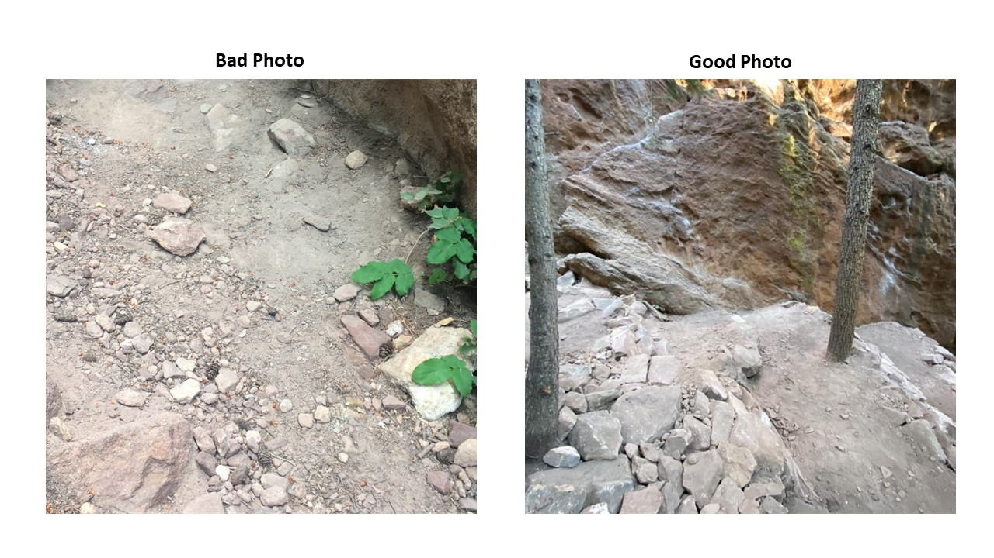

**Additional Information:**

1. Has all reconnaissance work, short of placing any hardware, been done?
2. Has the route been top roped? Is there loose rock? Is it extremely overhanging? If any “cleaning” of the route is required, please describe what that translates to. For example: “There are four dinner plate-sized loose flakes that will need to be removed, as well as several fist-sized blocks on a ledge.” Do you recommend adding any additional hardware other than bolts (e.g. mussy hooks, perma-draws)? These items will be considered for safety purposes and require additional review. If yes, how many are proposed and where are they located on the route? **Gluing or bolting loose rocks or holds in place is not permitted.**

Please include a photo or diagram of the rock formation with the proposed route drawn in and all hardware points labeled including those other than bolts (e.g. mussy hooks, perma-draws).

Please include any additional notes for the review committee here:

**Disclaimer and Release:**

I have applied to Open Space and Mountain Parks staff for a permit to place fixed climbing hardware at the described location. I am performing this function of my own accord. I will notify Open Space and Mountain Parks staff as stated above.

The City of Boulder is not responsible for the placement of fixed climbing hardware, and is not responsible for its maintenance, replacement, or safety. The bolts, fixed protection, or any other gear left behind are not facilities within Open Space and Mountain Parks land. People engaged in climbing activities do so at their own risk. The City of Boulder has not requested that I place any fixed climbing hardware, and I am not obligated by this notification to place any fixed climbing hardware. I am acting solely for my own purposes, and not acting as a contractor, agent, employee, or authorized volunteer of the City of Boulder in placing any fixed climbing hardware. The City of Boulder is not liable for any injury to the me arising out of placement of any fixed climbing hardware. The City of Boulder will not defend or indemnify me in any litigation which might arise out of the placement of any fixed climbing hardware. I am proceeding at my own risk and recognize and voluntarily assumed all risks to myself involved in the placement of fixed climbing hardware, which could include serious injury or death. I release the City of Boulder, and its officers and employees, from any liability they might have, or Applicant might claim from any of my acts or omissions to place any fixed climbing hardware. Further I agree to indemnify, defend and hold harmless the City of Boulder against any claims already made and claims that may be made in the future arising out of placing any fixed climbing hardware. I have read this disclaimer and release, agree to be bound by its terms, and will not assert any inconsistent position in any litigation arising out of the placement of any fixed climbing hardware.

(Applicant Signature - required) (Date Signed)