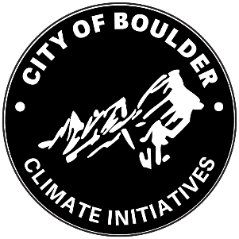
Healthy Buildings, Stronger Community ROADMAP
2025
Making existing buildings healthy, efficient and resilient for everyone.
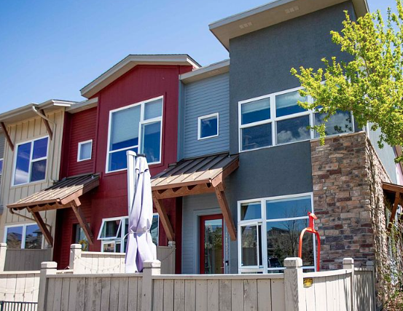
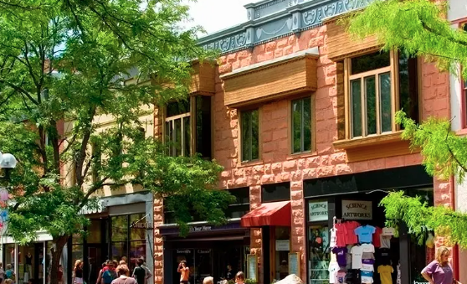
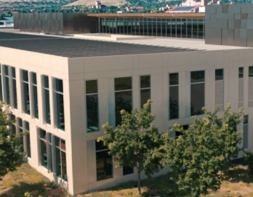
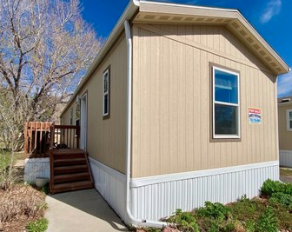
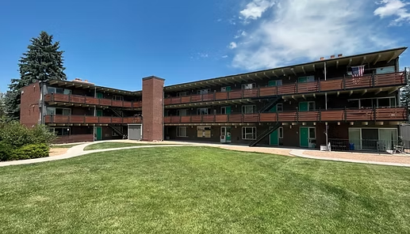

Acknowledgements
The City of Boulder Climate Initiatives Department extends its sincere appreciation to the following organizations and individuals for your time and input into the development of this roadmap.
- The 11 individuals who participated in in-depth interviews.
- The 60 individuals who participated in focus groups.
- The 536 individuals who completed the community questionnaire.
- The three organizations that provided time and space for Roadmap presentations.
- The Community Connectors-in-Residence who advised the project team on how to better reach diverse small business owners.
- Members of the 2024 and 2025 Environmental Advisory Board.
- Members of the 2025 Housing Advisory Board.
- Members of the 2025 City Council.
- The various organizations that supported our efforts to encourage community participation in the Roadmap questionnaire.
Additionally, we thank our skilled consultants. We couldn’t have done it without you!

Table of Contents
A. Executive Summary 1
The Roadmap Goals 1
A Call to Reinvest in Buildings 2
B. Process to Develop the Roadmap 2
Step 1. Define the issue before embarking. 2
Step 2. Determine who is affected. 2
Step 3. Create a public engagement plan. 2
Step 4. Create a foundation of information and inquiry. 3
Step 5. Identify options. 3
Step 6. Evaluate options and develop recommendations. 3
Step 7. Make a decision. 3
Step 8. Communicate decision and rationale. 3
Step 9. Reflect and evaluate. 3
C. Background 4
Why a roadmap? 4
Equity Considerations and Guardrails 4
Equity-priority Buildings 5
Building Stock Analysis 6
Energy Conservation Measures (ECMs) to Achieve Net-Zero Emissions 6
The Cost of Building Upgrades 7
Policy Review 7
Engagement 8
D. The Roadmap (2026 to 2035) 9

Executive Summary

The Roadmap Goals
This Roadmap outlines the city’s next generation of strategies to reduce emissions from existing buildings and further Boulder climate targets.

The city’s 2024 GHG inventory found that energy use by the city’s commercial and residential buildings produced nearly two-thirds (64%) of all GHG emissions. Annual emissions have declined 29% from the 2018 benchmark. This is meaningful progress, but to achieve the net-zero GHG emission goal by 2035, the city must accelerate efforts. In addition to meeting climate goals, the city seeks to:
Figure 1. Roadmap Goals

A Call to Reinvest in Buildings
Reinvesting in existing buildings isn’t just good for our climate, it’s good for people. Since the 1960s and 1970s, temperatures in Boulder have climbed two degrees Fahrenheit. A 2014 NOAA study predicted that by 2050 Boulder’s average temperature could be more like Albuquerque, New Mexico. Already the number of days over 90 degrees has increased. Yet half of Boulder’s buildings lack central air conditioning, and 25% of mobile homes lack cooling entirely. Extreme weather events are increasing too. Cooling access is less of a luxury today and more of a matter of safety. This roadmap promotes the vision of a healthy, efficient and equitable built environment, essential not just to reach net-zero carbon emissions, but to also advancing affordability, community resilience, and comfort.

Process to Develop the Roadmap
The staff team was guided by the city’s Nine-Step Engagement Process in the development of the roadmap.

Step 1. Define the issue before embarking.
The roadmap goals in Figure 1 were defined at project onset because:
- The current building efficiency and carbon reduction strategies will not achieve the goal of net-zero GHG emissions by 2035 and
- The programs and policies in place today were implemented before the city’s Racial Equity Plan and the Sustainability, Equity and Resilience Framework were adopted.

Step 2. Determine who is affected.
Those who must live with our future climate are impacted by today’s choices around GHG emissions, but the primary stakeholders of existing building regulations are those who live in, work in and own buildings in Boulder. This includes a very long and diverse list of household types, ages, roles in the community, businesses, building owners, occupations and more. Project staff worked with the Racial Equity Instrument to begin to identify equity priority stakeholders, listed later in this roadmap.

Step 3. Create a public engagement plan.
City staff developed a public engagement plan and identified “consult” as the appropriate level of stakeholder engagement at this preliminary stage of roadmap development. Consult means “to inform and seek feedback on drafts and proposals.” Through a competitive Request for Proposals (RFP), the Roadmap team selected a community engagement consultant. Engagement activities are described later in this document. Also, staff attended three Environmental Advisory Board meetings, a Housing Advisory Board meeting, a Community Connectors-in-Residence meeting and a City Council Study Session.

Step 4. Create a foundation of information and inquiry.
A technical consultant prepared the core of the foundation of information and inquiry, which includes a building stock analysis, policy review and financial analysis. Staff also shared summaries of existing policies and programs on the project website.

Step 5. Identify options.
Based on the analysis performed (Step 4 above), the technical consultant recommended policies, programs and initiatives to achieve the roadmap goals.

Step 6. Evaluate options and develop recommendations.
The recommendations (Step 5 above) informed the discussion in 16 focus groups conducted by the engagement consultant. Both the technical analysis and community engagement informed staff’s recommendations.

Step 7. Make a decision.
This roadmap requires department-level approval, not formal adoption, however several proposed items require future City Council approval. At the August 28, 2025 Study Session, staff presented the draft approaches to City Council. This feedback informed the Roadmap.

Step 8. Communicate decision and rationale.
This document serves to communicate both the decision and rationale. It will be available on the project webpage and distributed to the project email list.

Step 9. Reflect and evaluate.
Prioritization of roadmap activities onto staff work plans occurs annually. Progress toward completion of the roadmap will be monitored.

Background

Why a Roadmap?
In 2024, when Boulder launched the roadmap effort, the city’s regulations and incentives had been effective in reducing emissions, lowering energy costs and improving building health, but efforts must accelerate to achieve our climate and resilience goals. The Roadmap process provides the opportunity to reflect on past actions and vision forward. How can we evolve our strategies, informed by current best practices, available technology solutions, building science, and community needs?

Equity Considerations and Guardrails
Buildings can impact the health, safety, housing security, economic stability and quality of life of those who own, live in and work in them. Without program supports and policy considerations, the following stakeholders could benefit or be burdened.
Figure 2. Who’s Affected? Those Expected to Benefit or At-risk of Burden

Equity-priority Buildings
Equity-priority buildings house one or more uses serving frontline community members. Frontline community members are defined as “more vulnerable to the impacts of climate change due to income, race, language, age, documentation status, disability and more.”
Equity-priority buildings include:
Deed-restricted affordable housing: Boulder has a goal that 15% of all housing units be permanently affordable by 2035. In 2024, 8.7% of our housing stock or 4,094 homes were permanently affordable. These include both homeowner (823) and rental (3,271) units and the following building types: multifamily (2,872), condominium (640), single-family (160), mobile home (120), townhome (99), duplex (55), rental cooperatives (53), fourplexes (33), and “other” (62).
Naturally Occurring Affordable Housing (NOAH): NOAH is defined as multifamily apartment buildings wherein rents for two-thirds (66%) or more of units in the building are affordable to households earning no more than 80% AMI.
Service Providers: Service providers that benefit frontline community members include, but are not limited to, advocacy organizations, after-school care centers, childcare centers, community centers, disability services, domestic violence services, emergency services, family support, food pantries, homeless shelters, immigration services, job training, affordable legal services, mental and behavioral health services, places of worship, rehabilitation providers, senior centers, supportive housing, transitional housing, shelters for women and children.

Building Stock Analysis
There are over 46,000 conditioned buildings in Boulder, comprising 130 million square feet.
Table 1. Boulder’s Building Stock
Building Category | Area (square feet) | Area (%) | GHG Emissions (%)
Commercial | 34 million | 28% | 75%
Multifamily | 42 million | 31% | 11%
Single-family | 54 million | 41% | 14%
All | 130 million | 100% | 100%

Though commercial buildings represent less than one-third of the square footage of buildings in Boulder, they produce three-quarters of GHG emissions from buildings. In the residential realm, single-family detached homes represent 38% of housing units, but 56% of both square footage and GHG emissions.
To understand the resilience of Boulder’s building stock, the analysis explored a variety of factors including vintage (age of building), location in a heat-risk area, cooling access, energy efficiency, and natural gas vs. all-electric appliances. The Building Stock Analysis is found in a separate document.

Energy Conservation Measures (ECMs) to Achieve Net-Zero Emissions
The technical consultant identified these energy conservation measures (ECMs) as necessary to achieve the city’s goal of net-zero GHG emissions by 2035.
Table 2. Energy Conservation Measures (ECMs)
What it is: | What it means:
Replace heating and cooling equipment. | Replace fossil-fuel HVAC and hot water heaters with electric HVAC and hot water heaters.
Improve building envelopes. | - Insulate roofs, walls and floors.  - Seal air leaks to prevent drafts around doors, windows and joints.  - Install more reflective roofing materials.
Replace other fossil-fuel appliances with electric options. | Replace fossil-fuel stoves, refrigerators, dryers, etc., with electric options.
Upgrade lighting. | Replace less efficient incandescent and fluorescent fixtures with LED options.

The Cost of Building Upgrades
Even when people are very concerned about GHG emissions, upfront cost often dictates decision-making when considering energy-efficiency improvements. The factors below are expected to make the financial decision to complete ECMs more appealing over the next decade.
- Natural gas prices are expected to rise significantly over the next 10 years due to increased domestic and export demand and the need to upgrade the natural gas system.
- Product costs for electric appliances, such as heat pumps, are expected to decrease.
- The skilled workforce is expected to grow, which should translate to lower costs to install all-electric equipment.
- City of Boulder and its partners like Boulder County, Energy Outreach Colorado, the Denver Regional Council of Governments (DRCOG) and the State of Colorado expect to offer generous energy-efficiency incentives to lower income household and other equity-priority building owners.
- Solar subscriptions and on-site solar reduce monthly utility costs.

Policy Review
The city has been a trailblazer, developing policies and programs to equitably advance the efficiency and resilience of existing buildings while reducing GHG emissions.
Table 3. Current Policies and Programs for Existing Buildings
Program (Year Begun) and Description | Impact
SmartRegs (2010): All rental housing in Boulder must meet basic energy efficiency standards to receive a rental license. | Annual energy saved:  1,935,500 Kilowatt hours  Equivalent annual energy use:  526 homes
Building Performance Ordinance, BPO (2015): Existing commercial and industrial buildings must report energy use every year, complete an energy assessment and cost-effective upgrades every 10 years, including one-time lighting upgrade. | O2 eliminated annually:  12,713 metric tons  Equivalent annual energy use:  5,122 homes
Healthy and Resilient Mobile Homes (2022): Wind damage and emergency repairs, and energy improvements for manufactured and mobile homes. | Repairs completed:  260+ homes

While the programs and policies in place in 2025 have been impactful, they are inadequate to meet the goal of net-zero emissions by 2035. To explore options, the technical consultant scanned and summarized policies and programs nationwide that are driving energy saving, resilience and equity. That Policy Review, which includes the consultant’s key takeaways, is in a separate document.

Engagement
Between October 2024 and June 2025, the city’s Roadmap engagement team contacted over 60,000 community members on topics related to the Roadmap. Various engagement activities were conducted and the reach of each is captured in this graphic.
Figure 3. Community Member Contacts

In addition to the above efforts, project staff presented at public meetings, including:
- 3 Environmental Advisory Board meetings
- 1 Housing Advisory Board meeting
- 1 Community Connectors-in-Residence meeting
- 1 City Council meeting
The Community Engagement Report, which includes recommendations and considerations, informed by engagement, is in a separate document. Aligned with the city’s commitment to meaningful engagement, as Roadmap policies and programs are developed, engagement will continue.

The Roadmap (2026 to 2035)
A roadmap is a strategic, high-level guide that outlines major goals, key efforts and timing. It connects a vision to activities, but it’s not meant to be rigid and must necessarily adapt with changing information. Activities are set to phases over a 10-year period, as follows.
Figure 4. Three Phases of Roadmap Policy Implementation
Phase 1. “Early Wins” (2026) | Phase 1 activities focus on immediate actions to reduce regulatory burden.
Phase 2. Mid-term Efforts (2027-29) | Phase 2 will focus on policy changes that require more analysis, evaluation and engagement to implement thoughtfully. They are less time-sensitive than Phase I efforts.
Phase 3. Later Efforts (2030-35) | Phase 3 will focus on smaller commercial and residential buildings.

On the next page is a high-level Roadmap policy timeline.

Figure 5. Healthy Buildings, Stronger Community Roadmap Policy Efforts, 2026-2035

Other Key City Activities, 2026 to 2035

Potential Policy, if Needed
- Consider adopting zero-NOx (nitrogen dioxide, nitric oxide) standards, if necessary to replacement all-electric requirements.

Equity Supports

Actively promote free resources to mobile home owners. Promote free energy-efficiency and electrification resources, solar subscriptions and bill assistance to owners of mobile homes.

Revise city-funded income-based incentives. Only offer rebates to homeowners under 150% of the Area Median Income (AMI) with generous rebates for households below 100% AMI.
- Mitigate displacement risk. Especially for low-income renters, work with Eviction Prevention and Rental Assistance Supports (EPRAS) Program to understand existing landlord approaches to in-place vs. at-turnover vs. relocation practices, use of tenant liaisons and resources to support temporary relocation.
- Use Voluntary Agreements to limit rent increases. Require landlords who receive city funding to stabilize rents for a certain period to prevent landlord pass-along costs from displacing tenants.
- Prioritize community solar for low-income households. Seek to expand access to community solar programs to reduce energy burdens for income-qualified residents.
- Small business and equity priority buildings. Continue to proactively promote resources and offer additional supports.

Financial Supports

Advocate for on-bill financing legislation. Support passage of state legislation to establish an On-bill Repayment program for energy-efficiency and electrification upgrades.

Targeted Efforts

Work with large industrial campuses. Three large industrial campuses produce a large share of GHG emissions from buildings in Boulder. Work with these industrial campuses to pursue emissions reduction and decarbonization.

Work with homeowners associations (HOAs). Work with interested HOAs to develop streamlined approaches to pursue efficient electric heating and cooling. In HOAs with attached walls especially, the need to secure approvals from property managers and HOA boards add can discourage homeowners from pursuing heating and cooling appliance upgrades.

Workforce Development Initiatives
Work through regional partnerships, including with Workforce Boulder County, the Denver Regional Council of Governments, Front Range Community College, and the school district to address workforce needs.

Expand Boulder’s Clean Energy Workforce. Increase training programs for heat pumps and solar installation to create local jobs and support small businesses.
- Support under-resources workers. Seek to provide wrap-around services, including transportation, childcare and career supports to reduce barriers to entry into clean energy jobs.

Navigation Supports
- Enhance navigation for city energy regulations. Establish a One-stop Shop to support building owners to navigate incentives, permits, securing contractors, and energy data reporting and to offer general guidance.

