

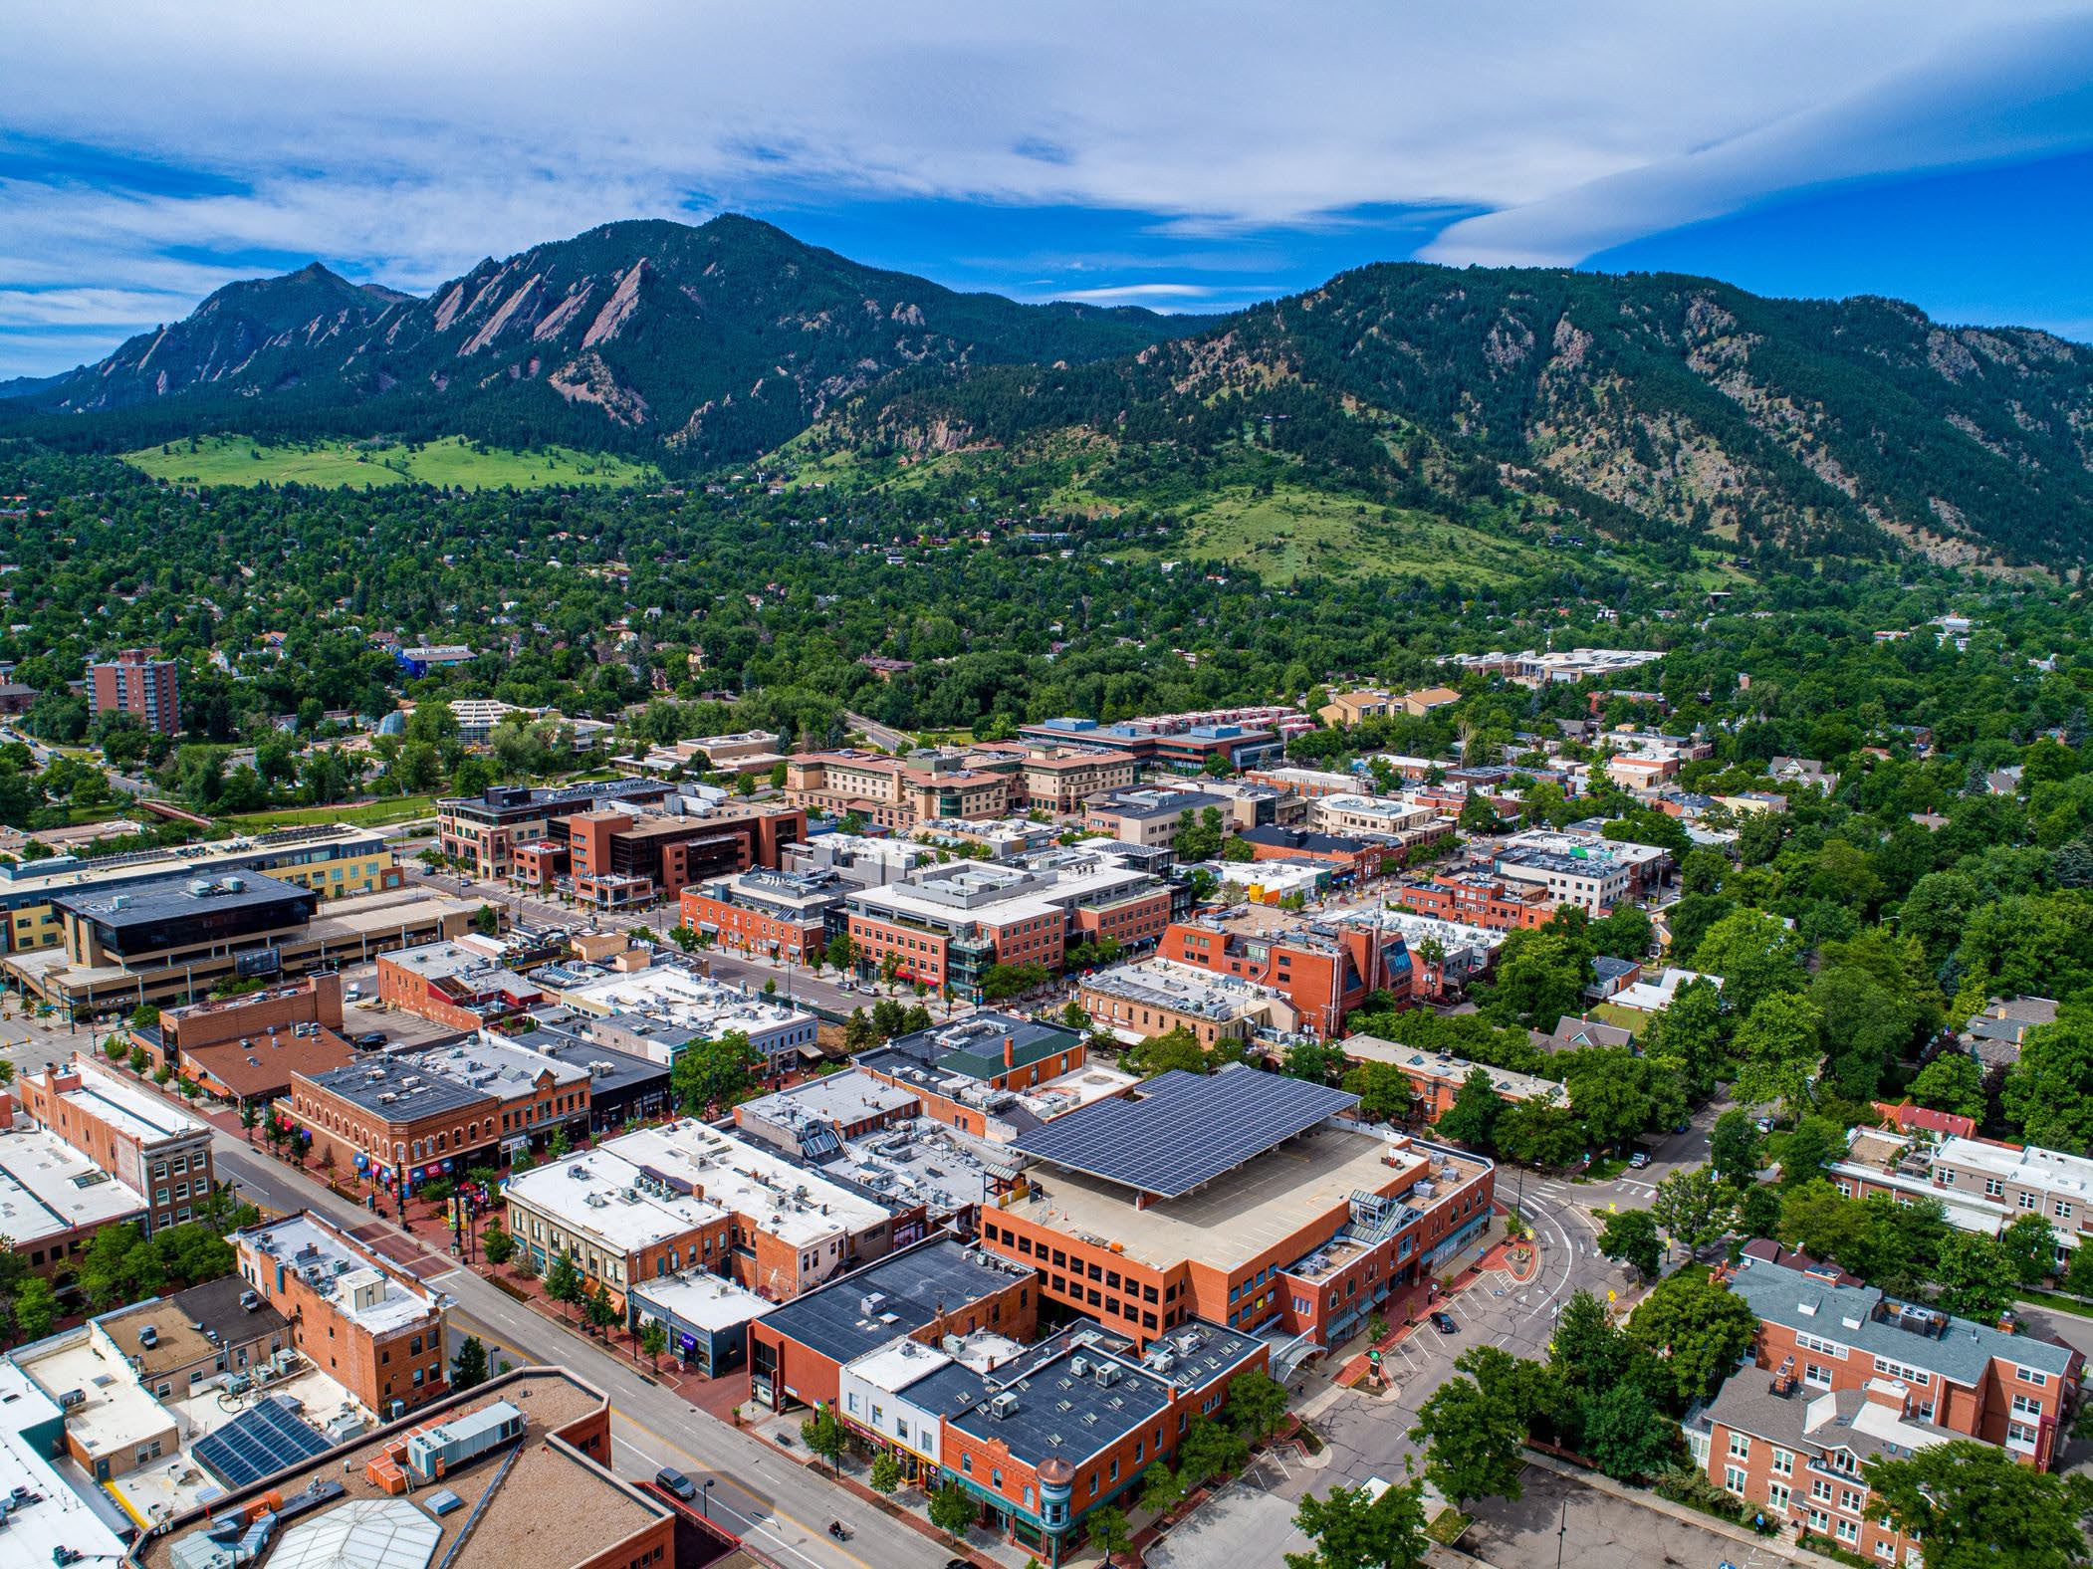

Photo Credit: slvnative. (2020, March 17)

City of Boulder

Healthy Buildings, Stronger Community

Building Stock Analysis

Table of Contents
- Executive Summary 3
- Introduction 4
- Current State of Boulder’s Buildings 5
- Emissions Profile 11
- Climate Risk and Health Implications 12
- Conclusion 14
References 15
Acknowledgements 15
Disclaimers 15

Executive Summary
The City of Boulder’s building stock is a critical driver of community greenhouse gas (GHG) emissions and a central focus for decarbonization planning. This analysis provides a baseline understanding of the size, age, and composition of the city’s residential and commercial buildings, as well as their associated energy use and emissions profiles. Together, these insights establish a foundation for identifying the most effective pathways to reduce emissions and improve building performance.
Boulder contains nearly 50,000 buildings with a combined floor area of approximately 130 million square feet. Residential buildings make up nearly three-quarters of this total, with single-family homes representing the largest share. Commercial buildings account for just over a quarter of total floor area but are responsible for the majority of building-related emissions. Current emissions factors indicate that commercial buildings contribute roughly 75 percent of portfolio emissions, driven by high energy use intensity and code-required ventilation loads.
Most of Boulder’s building stock dates from 1980 to 2009, meaning much of the city’s equipment is now at or near the end of its useful life. This creates both challenges, in terms of aging systems and degraded performance, and opportunities for upgrades that can support decarbonization. Residential trends show that single-family homes are somewhat older, with construction peaking in the 1990s, while multi-family housing is generally newer, with much of it built after 2000. Mobile homes, although a small portion of the stock, are older and may present elevated performance risks. Commercial construction peaked between 1970 and 1989, particularly in office, retail, and institutional buildings, and has slowed in recent decades.
Energy and emissions data further highlight the scale of the challenge. Residential buildings in Boulder have emissions intensities that generally fall between 5 and 7 lbs CO₂e per square foot per year, depending on typology. In contrast, commercial buildings average 18.6 lbs CO₂e per square foot per year, roughly three times higher than residential. Of the 646,000 tons of CO₂e from commercial buildings, 62 percent is Scope 2 (purchased electricity) and 38 percent is Scope 1 (on-site combustion). Residential emissions total about 214,000 tons CO₂e and are more heavily weighted to Scope 1, which makes up 61 percent of the residential total. This reflects widespread on-site use of natural gas for heating in the residential sector, while commercial emissions are driven more by electricity use.
This baseline analysis underscores the outsized role that commercial buildings play in Boulder’s emissions profile and the differing challenges presented by the residential sector. Commercial buildings dominate overall emissions despite representing a smaller share of total floor area, while residential buildings are more numerous and rely more heavily on on-site combustion. Together, these patterns point to distinct opportunities for reducing emissions across both sectors. The results provide a clear picture of where emissions are concentrated, how building age and typology shape performance, and which parts of the building stock may be most critical to address to achieve meaningful reductions in Boulder’s community-wide emissions.

Introduction
Buildings are central to Boulder’s climate and resilience goals. They account for the largest share of the city’s energy use and greenhouse gas (GHG) emissions, while also shaping daily comfort, affordability, and health for residents and businesses. Understanding the makeup and performance of Boulder’s building stock is a critical first step in planning effective pathways for decarbonization.
This report provides a summary of Boulder’s building portfolio, establishing a baseline of existing conditions, energy use, and emissions. The analysis combines multiple data sources, including property tax records, citywide energy usage, and national modeling tools such as ResStock and ComStock. The data were refined through typology mapping, building area assessments, HVAC system distributions, and emissions factors calibrated to local utility records.
While this report does not recommend specific policies or programs, it provides the baseline evidence needed to identify opportunities for electrification, energy efficiency, and renewable energy adoption across the city’s building portfolio. These findings inform the broader decarbonization roadmap, where strategies and actions are explored in greater detail.

Current State of Boulder’s Buildings
The City of Boulder buildings portfolio comprises of over 46,000 assets across the entire city. Most of the portfolio comprises residential properties, which represent 95 million of the 130 million ft2 of the portfolio, or roughly 73% of all built area. The balance of the portfolio consists of a range of discrete commercial building typologies. Multiple portfolio characteristics may be considered to inform the project understanding and the basis for decarbonization testing and planning. This sub-section summarizes some of the key parameters used to identify, test, and recommend decarbonization approaches for the city.

PORTFOLIO SNAPSHOT
Assets  Over 46,000 in-scope assets  Over 130 million ft2 |  | Commercial  Over 34 million ft2 of property  42 different commercial building typologies |  | Housing  Over 95 million ft2 of property Comprised of single family, multi-family, and mobile home typologies |  | Key Features  Over half of residential properties are single-family units.

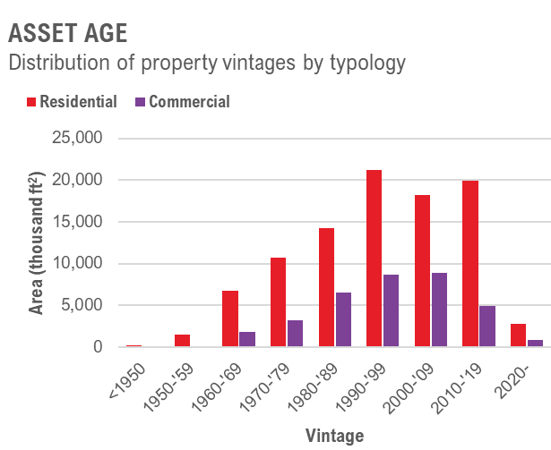
PORTFOLIO ASSET AGES
“Turn of the century” assets (built between 1980-2009) comprise the majority of properties.
Commercial
Over two-thirds (69%) of commercial properties date from 1980-2009.
Very few assets pre-date 1960.
Residential
Residential property is slightly newer, with 62% dating from 1990-
2019.
Over a third (35%) of properties are over 34 years old (pre-date 1990).

ALL BUILDING TYPOLOGY AGES
Distribution of all typology vintages

5,000
4,500
4,000
Number of Buildings
3,500
3,000
2,500
2,000
1,500
1,000
500
-
1950
1952
1954
1956
1958
1960
1962
1964
1966
1968
1970
1972
1974
1976
1978
1980
1982
1984
1986
1988
1990
1992
1994
1996
1998
2000
2002
2004
2006
2008
2010
2012
2014
2016
2018
2020
2022

Vintage

Single-Family Detached Single Family Attached Multifamily 5+ Units
Mobile Home Commercial < 50,000sf Commercial > 50,000sf

Building Characteristics
Most of both commercial and residential properties date between 1980 and 2009 and are therefore between 15 and 44 years old. As a result, it is anticipated that even the newer among these subsets may be approaching (or have already passed) the end of useful life for initially installed equipment or may be at risk of degraded performance due to age. A very small portion of residential assets predate 1930 (or roughly 228,000 ft2). While less than 1% of residential assets, this group of properties may be at more elevated risk of age-related performance degradation.
The distribution of building vintages in Boulder reflects a combination of local infrastructure improvements, national economic cycles, and the city’s evolving role in the Front Range. Early post-war growth in the 1950s was strongly influenced by the opening of the Denver–Boulder Turnpike in 1952, which dramatically improved access to Denver and catalyzed suburban-style residential development in Boulder. Construction activity continued into the 1960s as population growth surged, though local policies such as the Blue Line (1959) and the creation of the open space sales tax (1967) also began to shape where growth could occur. The chart shows noticeable slowdowns during periods of national economic stress, including the late 1970s and late 1980s, when high interest rates and broader recessions constrained new investment.
A renewed wave of construction appears in the 1990s and early 2000s, coinciding with the technology boom along the Front Range. As Boulder became a hub for high-tech firms, research institutions, and university-driven growth, demand for housing and commercial space accelerated. The spike in activity around the turn of the century mirrors national patterns tied to favorable financing conditions before the housing crash. The sharp decline after 2008 aligns with the Great Recession, when construction slowed nationwide. Since then, the gradual rebound in the 2010s reflects recovery in the broader economy and growing pressure for infill and multifamily development within Boulder’s growth boundaries, rather than large-scale expansion at the city’s edges.

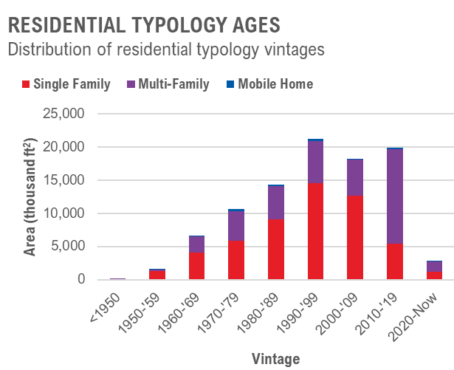
RESIDENTIAL TYPOLOGY AGES
Mobile homes tend to be the oldest; multi-family, the newest.
Single-Family
27% of single-family homes were built between 1990-1999.
Only 12% of home were built in the past 15 years.
Multi-Family
Over half (53%) of multi-family properties have been built since 2000.
Over a third (39%) of properties were built after 2010.
Mobile Home
Most (27%) of mobile homes were built between 1970-1979.
The vast majority (72%) of mobile homes pre-date 2000.

Residential Building Stock
Detailed examination of the residential building stock reveals a greater degree of nuance. Residential building stock in Boulder is generally divided into three (3) typologies:
- Single-family homes
- Multi-family homes
- Mobile homes

Single-family homes comprise the bulk of the Boulder housing stock, representing over 54 million ft2 of housing, or 56% of the entire residential portfolio. In contrast, mobile homes represent only 1%, just over 1 million ft2, of Boulder housing stock. Multi-family buildings represent 40 million ft2 of housing, or 43% of the residential portfolio. Beyond the relative size of each typology within the portfolio, however, there are relative differences in the age characteristics of these properties. Most single-family homes were built in the 1990s. When accounting for construction until the present, over half of all single-family homes have been built since 1990. However, multi-family properties tend to be even newer. Over 53% of all multi-family assets were built post-2000, with the decade from 2010 to 2019 alone representing 35% of all multi-family constructions. These trends contrast sharply with the construction years of mobile homes. Most mobile homes were built between 1970 and 1979, which means that 27% of all mobile homes are between 45 and 54 years old. Less than a fifth of mobile homes have been built in the past 15 years. The resultant assumption is that of all the residential typologies, mobile homes likely display the greatest risk potential for degraded envelope and building system performance given their relative age.

COMMERCIAL TYPOLOGY AGES
COMMERCIAL TYPOLOGY AGES
Nearly two-thirds of commercial space pre-date 2000.
Commercial Office
Largest share of commercial space with strongest growth in the ‘70s and ‘80s
Hotels
Smallest share of commercial stock overall with concentrated development in the ‘80s.
Retail + Food
Most consistent construction throughout recent decades, representing and increasing share up until the 2008 crisis.

Distribution of commercial typology vintages
Office Retail + Food Education Healthcare Hotel 16,000
14,000
Are a (thousand ft 2)
12,000
10,000
8,000
6,000
4,000
2,000
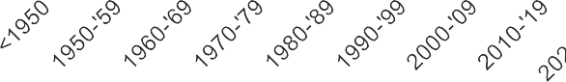
-
Vintage

Commercial Building Stock
A review of Boulder’s commercial building stock highlights both the diversity of uses and the concentration of construction in earlier decades. The primary commercial building categories are:
- Office
- Retail + Food
- Education
- Healthcare
- Hotel
Office space is the single largest commercial typology, representing a substantial share of the total square footage and showing consistent construction across all decades. Retail and food service, along with education and healthcare, are also significant contributors to the commercial portfolio. The largest wave of commercial construction occurred between 1970 and 1989, when over a third of all current commercial floor area was developed. Since 2000, new commercial construction has slowed, with modest additions concentrated in retail, office, and healthcare properties. Compared to residential buildings, the commercial portfolio is generally older: nearly two-thirds of commercial space pre-dates 2000. This means that many commercial assets may now be approaching key equipment replacement cycles and could present higher opportunities for system modernization and decarbonization upgrades.

Building Portfolio
To place Boulder’s building stock into context, it is helpful to compare performance by building type. The following tables summarize building counts and total floor area for each typology, alongside typical energy use intensity (EUI) and carbon emission intensity (CEI). This comparison highlights both the scale of each building category and the relative differences in energy and emissions performance. While residential buildings represent the majority of total area, commercial and institutional buildings drive most of the community’s emissions. High-intensity uses such as office, retail, and education account for a disproportionate share, while smaller categories like hotels or healthcare, though limited in area, also show relatively high EUI and CEI values. These results provide a baseline view of where emissions are concentrated and which building types represent the greatest opportunities for decarbonization.

Table 1. Boulder Residential Building Stock Summary with derived EUI and emissions estimates

Residential Building Type | Building Count | Total GFA (ft2) | Aggregated Elec. EUI (kbtu/sf) | Aggregated Gas. EUI  (kbtu/sf) | Total EUI (kbtu/sf) | Electricity emissions (tons) | Gas emissions (tons) | Emissions intensity (lbs/sf)
Mobile Home | 1,362 | 1,299,473 | 9.7 | 30.3 | 40.0 | 1,699 | 2,302 | 6
Multi Family - 9+ Units | 781 | 24,509,808 | 13.9 | 14.4 | 28.3 | 45,711 | 20,680 | 5
Multi Family - <9 Units | 2,236 | 3,760,522 | 15.5 | 20.5 | 36.0 | 7,846 | 4,504 | 7
Single Family - Attached | 4,872 | 6,365,577 | 10.5 | 20.4 | 30.9 | 8,954 | 7,591 | 5
Single Family - Detached | 3,3918 | 59,907,499 | 9.7 | 27.0 | 36.7 | 77,924 | 94,617 | 6

Table 2. Boulder Commercial Building Stock Summary with derived EUI and emissions estimates

Commercial Building Type | Building Count | Total GFA (ft2) | Aggregated Elec. EUI (kbtu/sf) | Aggregated Gas. EUI  (kbtu/sf) | Total EUI (kbtu/sf) | Electricity emissions (tons) | Gas emissions (tons) | Emissions intensity (lbs/sf)
Agricultural | 34 | 316,270 | 21.9 | 12.5 | 34.4 | 933 | 232 | 7
Auto Shop | 33 | 339,674 | 110.1 | 15.2 | 125.3 | 5,033 | 302 | 31
Bank | 28 | 176,460 | 38.6 | 19.1 | 57.7 | 916 | 197 | 13
Car Wash | 16 | 24,026 | 90.3 | 68.2 | 158.6 | 292 | 96 | 32
Church / Assembly | 50 | 384,691 | 35.6 | 31.3 | 66.8 | 1,840 | 704 | 13
Convention Center | 1 | 5,368 | 89.8 | 68.4 | 158.2 | 65 | 21 | 32
Correctional Facility | 1 | 8,956 | 44.2 | 25.3 | 69.5 | 53 | 13 | 15
Daycare | 26 | 103,829 | 27.8 | 24.1 | 51.9 | 389 | 146 | 10
Fire Station | 14 | 30,951 | 49.4 | 21.4 | 70.8 | 206 | 39 | 16
Food Service - Bar | 7 | 35,211 | 165.1 | 173.9 | 339.0 | 782 | 358 | 65

Commercial Building Type | Building Count | Total GFA (ft2) | Aggregated Elec. EUI (kbtu/sf) | Aggregated Gas. EUI  (kbtu/sf) | Total EUI (kbtu/sf) | Electricity emissions (tons) | Gas emissions (tons) | Emissions intensity (lbs/sf)
Food Service - Fast Food | 14 | 40,011 | 184.6 | 146.7 | 331.4 | 994 | 343 | 67
Food Service - Restaurant | 116 | 611,674 | 175.2 | 166.7 | 341.9 | 14,418 | 5,962 | 67
Greenhouse | 35 | 56,000 | 21.2 | 11.4 | 32.6 | 159 | 37 | 7
Hotel | 58 | 2,033,258 | 51.2 | 26.2 | 77.4 | 14,007 | 3,117 | 17
Industrial  /Manufacturing | 406 | 9,260,866 | 32.2 | 14.2 | 46.4 | 40,145 | 7,694 | 10
Library | 5 | 14,435 | 36.7 | 26.6 | 63.3 | 71 | 22 | 13
Medical - Clinic | 25 | 59,773 | 52.5 | 18.9 | 71.4 | 422 | 66 | 16
Medical - Hospital | 1 | 34,310 | 55.4 | 36.4 | 91.8 | 256 | 73 | 19
Medical - Mortuary | 3 | 26,019 | 51.5 | 21.4 | 72.9 | 180 | 33 | 16
Medical - Office | 133 | 978,402 | 52.3 | 18.5 | 70.8 | 6,888 | 1,056 | 16
Medical - Veterinarian | 6 | 23,833 | 51.7 | 22.1 | 73.8 | 166 | 31 | 17
Museum | 1 | 1,923 | 76.8 | 50.3 | 127.2 | 20 | 6 | 27
Office | 989 | 12,660,623 | 39.6 | 14.0 | 53.6 | 67,419 | 10,380 | 12
Post Office | 3 | 36,072 | 41.7 | 19.5 | 61.2 | 202 | 41 | 13
Recreation/Fitne ss | 28 | 583,077 | 49.0 | 49.6 | 98.7 | 3,846 | 1,692 | 19
Retail - Auto | 49 | 425,070 | 40.7 | 18.4 | 59.2 | 2,328 | 458 | 13
Retail - Big Box | 5 | 358,355 | 40.4 | 17.2 | 57.6 | 1,948 | 360 | 13
Retail - Convenience | 27 | 42,309 | 118.1 | 93.4 | 211.6 | 672 | 231 | 43
Retail - General | 380 | 3,415,438 | 57.8 | 26.9 | 84.7 | 26,575 | 5,367 | 19
Retail - Grocery | 16 | 600,261 | 107.8 | 79.8 | 187.6 | 8,705 | 2,802 | 38
School | 99 | 361,647 | 29.4 | 32.6 | 62.1 | 1,433 | 690 | 12
Theater - Cinema | 4 | 96,333 | 81.3 | 55.1 | 136.4 | 1,054 | 310 | 28
Theater - Stage | 3 | 45,833 | 80.5 | 55.2 | 135.7 | 496 | 148 | 28
Utility | 86 | 742,581 | 21.6 | 12.1 | 33.6 | 2,155 | 524 | 7
Warehouse - Distribution | 135 | 2,596,008 | 21.5 | 11.9 | 33.3 | 7,499 | 1,799 | 7
Warehouse - Refrigerated | 2 | 336 | 221.0 | 11.4 | 232.3 | 10 | 0 | 61
Warehouse - Storage | 126 | 640,920 | 21.4 | 11.8 | 33.2 | 1,848 | 441 | 7

Emissions Profile
Though residential buildings make up a much larger share of Boulder’s stock, commercial buildings are much more emissions-intensive per area. They represent only 28% of total floor area but 48% of buildings-related emissions (emissions associated with building energy consumption and not industrial processes). Meanwhile, residential accounts for nearly three-quarters of floor area yet only 52% of buildings-related emissions. On an area-normalized basis, residential buildings average 2.2 kg CO2e/ft²/yr compared to 5.5 kg CO2e/ft²/yr for commercial, almost three times higher. This reflects the wide range of programs included under “commercial” and explains why, despite being a smaller portion of total area, commercial buildings dominate portfolio emissions.
Baselining shows low electrification rates across both sectors, but with different implications. Of 205,159 tonnes of CO2e from commercial properties, 80% is Scope 2 (purchased electricity) and 20% is Scope 1 (on-site combustion). Residential buildings, in contrast, have Scope 1 emissions that make up 53% of their total, indicating broader use of on-site combustion. This split reflects differences in building operations: commercial buildings generally have higher heating and cooling demands due to ventilation requirements and high occupant densities, as well as more process loads (e.g. things plugged into outlets and used in offices, kitchens, salerooms, etc).

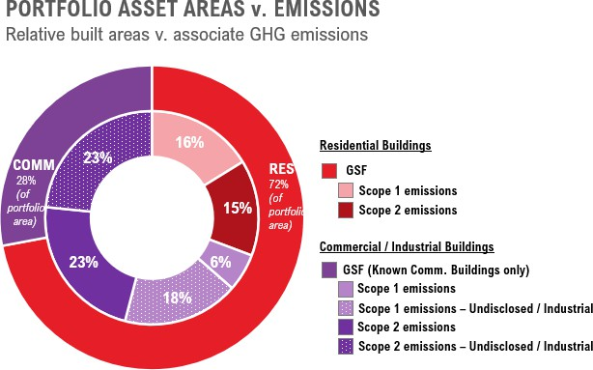
PORTFOLIO EMISSIONS
Commercial buildings are only 28% of the portfolio by area, but are over twice as emissions-intensive (per GSF) than Residential buildings.
Commercial
28% of portfolio GSF (>95m ft2)
205,159 tonnes CO2e
typical CEI: 5.5 kg CO2e/ft²
48% of buildings-based emissions
20% of which are Scope 1 (on-site gas/propane combustion)
Residential
72% of portfolio GSF (>34m ft2)
223,142 tonnes CO2e
typical CEI: 2.3 kg CO2e/ft²
52% of buildings-based emissions
53% of which are Scope 1 (on-site gas/propane combustion)

Climate Risk and Health Implications
The quality and availability of the residential building stock plays a critical role in the health, safety, and well-being of Boulder residents. Housing needs to be resilient to escalating climate impacts, facilitating adaptability to changing conditions and ensuring the long-term livability and durability of housing assets. Chief among adaptation concerns in Boulder is protecting residents through increasing temperatures resulting from climate change and localized climate hazards like the urban heat island (UHI) effect. This is also pertinent given the City’s stated objective of provisioning “Cooling for All” as part of providing climate resilient housing.
Regarding Boulder residents, some may have vulnerabilities relating to age, health, and/or income that could place them at greater risk of either being able to afford energy or emissions efficiency measures (or pay base utility costs), or be exposed to greater climate change risks as a result of not being able to afford certain active measures necessary for adaptation (e.g., a window A/C unit, first cost, and associated utility bill increase).
Of the analyzed residential building stock, climate hazards are more significant challenges to decarbonization than occupant vulnerabilities. Portions of residential buildings are located in areas of either urban heat or wildfire exposure. In terms of occupant vulnerabilities, housing cost burden is the most prevalent challenge, followed respectively by asthma rates, then low-income thresholds.

VULNERABILITY AND CLIMATE HAZARD SNAPSHOT¹
Burden Thresholds  URBAN HEAT ANOMALY  23% of single- and 27% of multi-family properties are located in an area with an urban heat risk  PROJECTED WILDFIRE RISK  74% of single- and 41% of multi-family properties are in a 30-year project wildfire risk area  ASTHMA  4% of each single- and multi-family property includes residents identified as having asthma |  | Socioeconomic Thresholds  LOW INCOME  1% of each single- and multi-family property is identified as households where the income is less than or equal to twice the federal poverty level  LOW-TO-MODERATE INCOME  6% of single- and 11% of multi-family property are defined as making less than 80% the area median family income

¹ All date per Climate and Economic Justice Screening Tool (including all definitions and risk thresholds).

Over half of all existing residential building stock in Boulder lacks some form of installed air-conditioning (“A/C”). Across the single- and multi-family housing typologies, generally half of each respective asset lacks installed A/C. Of the mobile home properties in the dataset, roughly 98% of units lack permanently installed A/C capacity. Our analysis also surveyed the areas of Boulder experiencing a UHI anomaly, comparing this to the residential typologies in each area of the city for which UHI data was reported.2 Installation of A/C to buildings without any cooling provides an opportunity to retire existing gas-fired heating systems and replace with a more efficient heat pump system that provides both heating and cooling. Layering the prevalence of A/C installations against areas with a UHI anomaly formed the final step of this heat risk assessment to identify residential assets representing the greatest imperative of heat resilience adaptation.
Based on the layering of these latter two parameters, approximately 13% of all residential assets are identified as “high risk” as pertains to urban heat risks, as these assets lacked both installed A/C and are located in areas with a UHI anomaly. Within the respective single- and multi-family typologies, these “high risk” assets represent roughly 6 million ft2 in part, or 12 million ft2 in aggregate. The entirety of this analysis is summarized in the figures below.
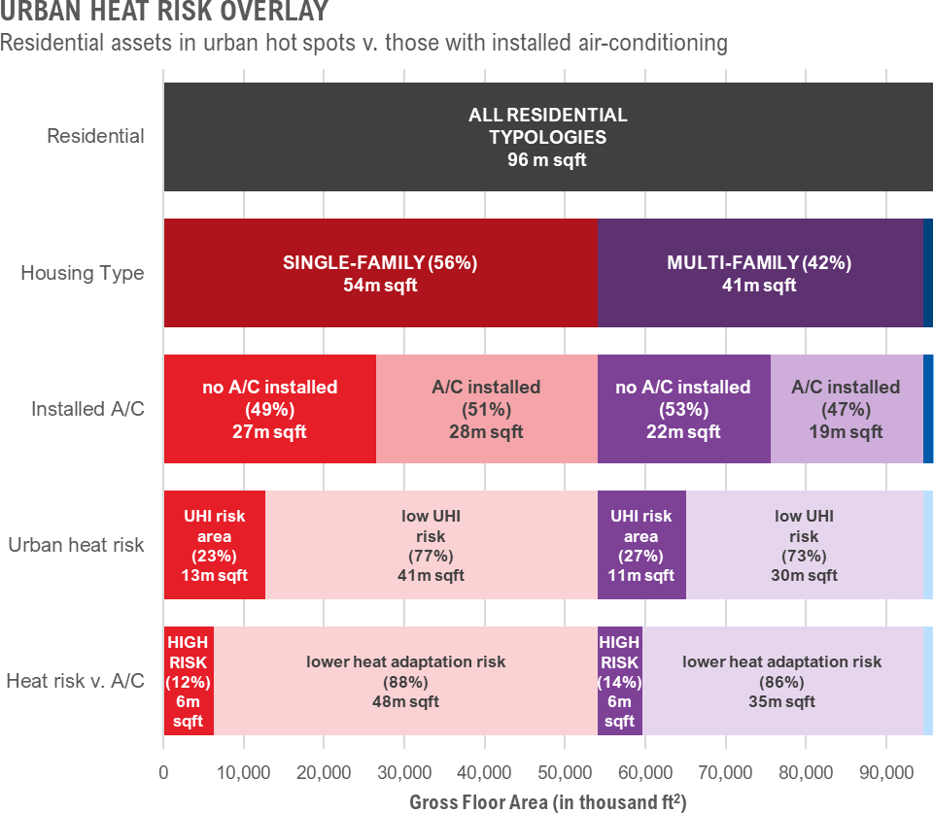
Figure 1. Urban Heat Risk Overlay

² Urban heat island data was sourced from the National Integrated Heat Health Information System.

Conclusion
This analysis establishes a data-driven foundation for Boulder’s building decarbonization roadmap. It provides a comprehensive view of the city’s existing building stock, including its size, age, composition, and associated emissions, revealing both the scale of the challenge and the opportunities ahead. Several key insights emerge.

First, the commercial sector, while representing only about one-quarter of total floor area, is responsible for nearly half of all building-related emissions. High energy intensities in office, retail, education, and food service buildings highlight where targeted retrofits, system replacements, and electrification efforts can have the greatest immediate impact. Many of these buildings were constructed before 2000 and are now approaching major equipment replacement cycles, presenting a near-term opportunity for intervention.

Second, the residential sector, which dominates in number and total floor area, presents a different challenge. Single-family homes are generally older and rely heavily on natural gas heating, while multi-family housing is newer and more electrically driven. Mobile homes, though a small share of the total, represent some of the least resilient housing in terms of both age and thermal performance.
Electrification and weatherization in this sector must balance emissions reduction goals with affordability, comfort, and equity considerations.

Third, the analysis identifies emerging risks related to climate and health. A significant share of residential properties lack cooling systems despite being located in areas with higher urban heat exposure. This underscores the need to align decarbonization with resilience. Replacing gas furnaces with heat pumps can provide both emissions benefits and heat adaptation capacity, especially for lower-income households.

Finally, Boulder’s building stock is entering a period of natural turnover as systems installed in the 1980s and 1990s have reached the end of their useful life. This transition provides a timely window for coordinated policy, incentive, and technical support that accelerates electrification and energy efficiency improvements while avoiding lock-in of new fossil-fuel infrastructure.

Together, these findings frame where and how the City of Boulder can act most effectively. They will inform the subsequent roadmap, which translates these insights into specific actions, policies, and investment priorities to advance Boulder’s goals for healthy buildings and a stronger community.

References
- Boulder Country Assessor Data
- Boulder County Open Data
- Boulder Building Performance Ordinance
- CDPHE (Colorado Department of Public Health)
- City of Boulder
- Xcel (Via City of Boulder)
- Radiant Labs Data (Via City of Boulder)
- Salesforce Data (Boulder dataset)
- ComStock (NREL)
- ResStock (NREL)

Acknowledgements

Authors:
Ben Brannon, Justin Lueker, and Nick Swedberg

Contributors:
Jack Daley, Joshua Radoff, Lingyi Chen, Caden Vitti, and other Arup Staff. Laurel Mattrey, Crystal Launder, Carolyn Elam, and other City staff.

Disclaimers
Arup is an engineering firm and does not provide legal advice. Any legal issues should be reviewed with the City’s legal counsel.

