Stormwater Control Measure
Inspection and Maintenance Guide

Prepared For:
Insert Site/Development Name and Address
Insert Property Owner Name and Contact

Prepared By:
Insert Preparing Engineer’s Name, Organization, and Contact

Table of Contents
1. Owner Responsibilities 1
2. Onsite Facilities 1
3. Inspection Requirements 1
4. Maintenance Activities 2
5. References 2
Attachment A. Maintenance Schedule and Description 3
Attachment B. Inspection Form 6
Attachment C. SCM Drawings 8

Directions for Preparer:
All highlighted text shall be provided by the Preparing Engineer. The enclosed sections shall at a minimum be provided. Where appropriate, additional information may be added to address specific site considerations or unique installations. This document is to be submitted as a formatted pdf appendix to the Final Drainage Report for City review and provided by the engineer to the property owner. All highlighted sections shall be modified and the highlighting removed prior to submission.

Owner Responsibilities
The owner of stormwater control measures (SCMs), also referred to as best management practices (BMPs), shall protect, inspect, maintain, repair, and reconstruct SCMs and associated drainage infrastructure on the property to ensure full, functional operation in accordance with the specifications of this Inspection and Maintenance Guide. In instances where inspection and maintenance duties have been assigned to a delegated representative via an agreement or contract, the owner maintains responsibility in ensuring the specifications of this guide have been carried out. The specifications of this Guide are pursuant to the following City of Boulder requirements:
- Boulder Revised Code (1981): Chapter 11-5, Stormwater and Flood Management Utility
- Boulder Design and Construction Standards (2019): Chapter 7-18, Post-Construction Stormwater Quality Inspection and Maintenance Requirements

Onsite Facilities
This Guide applies to the following SCMs on the property:
- Name 1: Provide a brief description of the facility including the SCM type, location, access points, and key functional components. The name of the facility should match drainage report descriptions and provided facility drawings (Attachment C)
- Name 2: Provide a brief description of the facility including the SCM type, location, access points, and key functional components. The name of the facility should match drainage report descriptions and provided facility drawings (Attachment C).
- Add additional rows as needed.

Inspection Requirements
A documented visual inspection of each SCM on the property is required per the documented inspection frequency listed in Table 1. Inspections shall be documented using the form(s) provided in Attachment B. The documented inspection shall be performed between May and August, when vegetation is not dormant and snow does not cover the SCM. Completed inspection forms shall be kept by the owner or their delegated representative for a minimum of five years and provided to the City of Boulder Stormwater Program upon request.
The City of Boulder Stormwater Program recommends that facility inspections be conducted by personnel certified for inspection and maintenance through the Colorado Stormwater Center Training Program.
The City of Boulder Stormwater Program will conduct routine oversight inspections of each SCM on the property to ensure the facilities are functioning as designed. The City will correspond with the owner or delegated representative when corrective actions are required. Failure to implement corrective actions may result in enforcement actions including civil penalties and/or criminal prosecution.
Table 1. Required SCM inspection frequency
Directions to Preparer: Remove or add rows to include each SCM on the property.
Name | SCM Type | Frequency
Name | Bioretention (Rain Garden) | Annually
Name | Constructed Wetland Channel | Annually
Name | Constructed Wetland Pond | Annually
Name | Extended Detention Basin | Annually
Name | Grass Buffer | Annually
Name | Grass Swale | Annually
Name | Permeable Pavement | Annually
Name | Receiving Pervious Area (RPA) | Annually
Name | Retention Pond | Annually
Name | Sand Filter | Annually
Name | Other SCM Design | Annually
Name | Underground/Proprietary SCM | Every 3 Months

Maintenance Activities
Maintenance is essential for SCMs to be effective. Maintenance activities include both routinely scheduled activities and periodic larger efforts to repair or restore system components. An effective routine maintenance program can prevent more costly repairs later on. As part of routine maintenance efforts, SCMs should be visually inspected to identify build-up or blockages of trash, debris, or sediment; check for damage; and determine current maintenance needs. SCMs should also be visually inspected after storms and snow melt to assess whether stormwater in the SCM is draining as expected.
The recommended maintenance schedule and description based on SCM type is provided in Attachment A. These recommendations are based on guidance from the Urban Drainage and Flood Control District (UDFCD) and the experience of the preparing engineer.
The City of Boulder Stormwater Program recommends inspection and maintenance personnel reference the Colorado Stormwater Center Inspection and Maintenance Field Guide for visual depictions of maintenance actions.

References
Colorado Stormwater Center. Permanent Stormwater Quality Best Management Practice Inspection and Maintenance Field Guide. n.d. Colorado State University. < http://stormwatercenter.colostate.edu/wp-content/uploads/2018/04/BMP_I-M_Manual_med.pdf>
Urban Drainage and Flood Control District (UDFCD). 2010. Urban Storm Drainage Criteria Manual (USDCM) Volume 3 Stormwater Quality. Chapter 6 BMP Maintenance. < https://udfcd.org/wp-content/uploads/2014/07/Chapter-6-BMP-Maintenance.pdf>

Attachment A. Maintenance Schedule and Description
Directions to Preparer: Insert the appropriate recommended maintenance schedule and description for the SCM type/s on the property. The maintenance schedules and descriptions provided by the City of Boulder are meant to serve as examples only, it is the responsibility of the preparing engineer to modify the maintenance schedule and description as needed to ensure proper operation for the specific facility.
Recommended Maintenance Schedule and Descriptions are available on the City of Boulder website at:
https://bouldercolorado.gov/water/stormwater-quality

Directions to Preparer: Extended detention basin maintenance schedule and description is provided as an example, and must be replaced or modified with appropriate SCM type.
Extended Detention Basin (EDB)
  - Recommended Maintenance Schedule and Description

Maintenance Schedule
Category | Element | Recommended Frequency
Routine | Visual Inspection | Twice annually following precipitation
 | Debris and Litter Removal | As needed, checked monthly
 | Aeration | Annually
 | Mowing and Plant Care | Every two weeks, seasonally dependent
 | Mosquito Control | As needed, checked weekly
 | Irrigation Scheduling and Maintenance | As needed, checked monthly
 | Sediment Removal from the Forebay, Trickle Channel, and Micropool | Annually
Rehabilitative | Sediment Removal from the Basin Bottom | As needed
 | Erosion and Structural Repairs | As needed

Visual Inspection
Visually inspect the EDB at least twice annually following precipitation events, observing the amount of sediment in the forebay and checking for debris at the outlet structure. EDB facilities are designed to drain the WQCV over approximately 48 hours. If standing water persists for more than 3 days after runoff has ceased, clogging should be further investigated and remedied.

Debris and Litter Removal
Remove debris and litter from the detention area as required to minimize clogging of the outlet.

Mowing and Plant Care
When starting from seed, mow native/drought tolerant grasses only when required to deter weeds during the first three years. Following this period, mowing of native/drought tolerant grass may stop or be reduced to maintain a height of no less than 6 inches (higher mowing heights are associated with deeper roots and greater drought tolerance). In general, mowing should be done as needed to maintain appropriate height and control weeds. Mowing of manicured grasses may vary from as frequently as weekly during the summer, to no mowing during the winter.

Aeration
For EDBs with manicured grass, aeration will supply the soil and roots with air and increase infiltration. It reduces soil compaction and helps control thatch while helping water move into the root zone. Aeration is done by punching holes in the ground using an aerator with hollow punches that pull the soil cores or "plugs" from the ground. Holes should be at least 2 inches deep and no more than 4 inches apart.
Aeration should be performed at least once per year when the ground is not frozen. Water the turf thoroughly prior to aeration. Mark sprinkler heads and shallow utilities such as irrigation lines and cable TV lines to ensure those lines will not be damaged. Avoid aerating in extremely hot and dry conditions. Heavy traffic areas may require aeration more frequently.

Mosquito Control
The Urban Drainage and Flood Control District recommended EDB design implements practices specifically developed to deter mosquito breeding, however, some level of mosquito control may be necessary if the facility is located in close proximity to outdoor amenities. The most effective mosquito control programs include weekly inspection for signs of mosquito breeding with treatment provided when breeding is found. These inspections can be performed by a mosquito control service and typically start in mid-May and extend to mid-September. Treatment should be targeted toward mosquito larvae. Mosquitoes are more difficult to control when they are adults. This typically requires neighborhood fogging with an insecticide.
The use of larvicidal briquettes or "dunks" may be appropriate. These are typically effective for about one month and perform best when the basin has a hard bottom (e.g., concrete lined micropool).

Irrigation Scheduling and Maintenance
Adjust irrigation throughout the growing season to provide the proper irrigation application rate to maintain healthy vegetation. Less irrigation is typically needed in early summer and fall, with more irrigation needed during July and August. Native grass and other drought tolerant plantings should not require irrigation after establishment.
Check for broken sprinkler heads and repair them, as needed. Completely drain the irrigation system before the first winter freeze each year. Upon reactivation of the irrigation system in the spring, inspect all components and replace damaged parts, as needed.

Sediment Removal from the Forebay, Trickle Channel, and Micropool
Remove sediment from the forebay and trickle channel annually. If portions of the watershed are not developed or if roadway or landscaping projects are taking place in the watershed, the required frequency of sediment removal in the forebay may be as often as after each storm event. The forebay should be maintained in such a way that it does not provide a significant source of resuspended sediment in the stormwater runoff. Sediment removal from the micropool is required about once every one to four years, and should occur when the depth of the pool has been reduced to approximately 18 inches. Small micropools may be vacuumed and larger pools may need to be pumped in order to remove all sediment from the micropool bottom. Removing sediment from the micropool will benefit mosquito control. Ensure that the sediment is disposed of properly and not placed elsewhere in the basin.

Sediment Removal from the Basin Bottom
Remove sediment from the bottom of the basin when accumulated sediment occupies about 20% of the water quality design volume or when sediment accumulation results in poor drainage within the basin. The required frequency may be every 15 to 25 years or more frequently in basins where construction activities are occurring.

Erosion and Structural Repair
Repair basin inlets, outlets, trickle channels, and all other structural components required for the basin to operate as intended. Repair and vegetate eroded areas as needed following inspection

Attachment B. Inspection Form
Directions to Preparer: Insert the appropriate inspection form for the SCM type/s on the property.
SCM Inspection Checklists are available on the City of Boulder website at:
https://bouldercolorado.gov/water/stormwater-quality

Directions to Preparer: Extended detention basin inspection form provided as example, replace with appropriate SCM type.
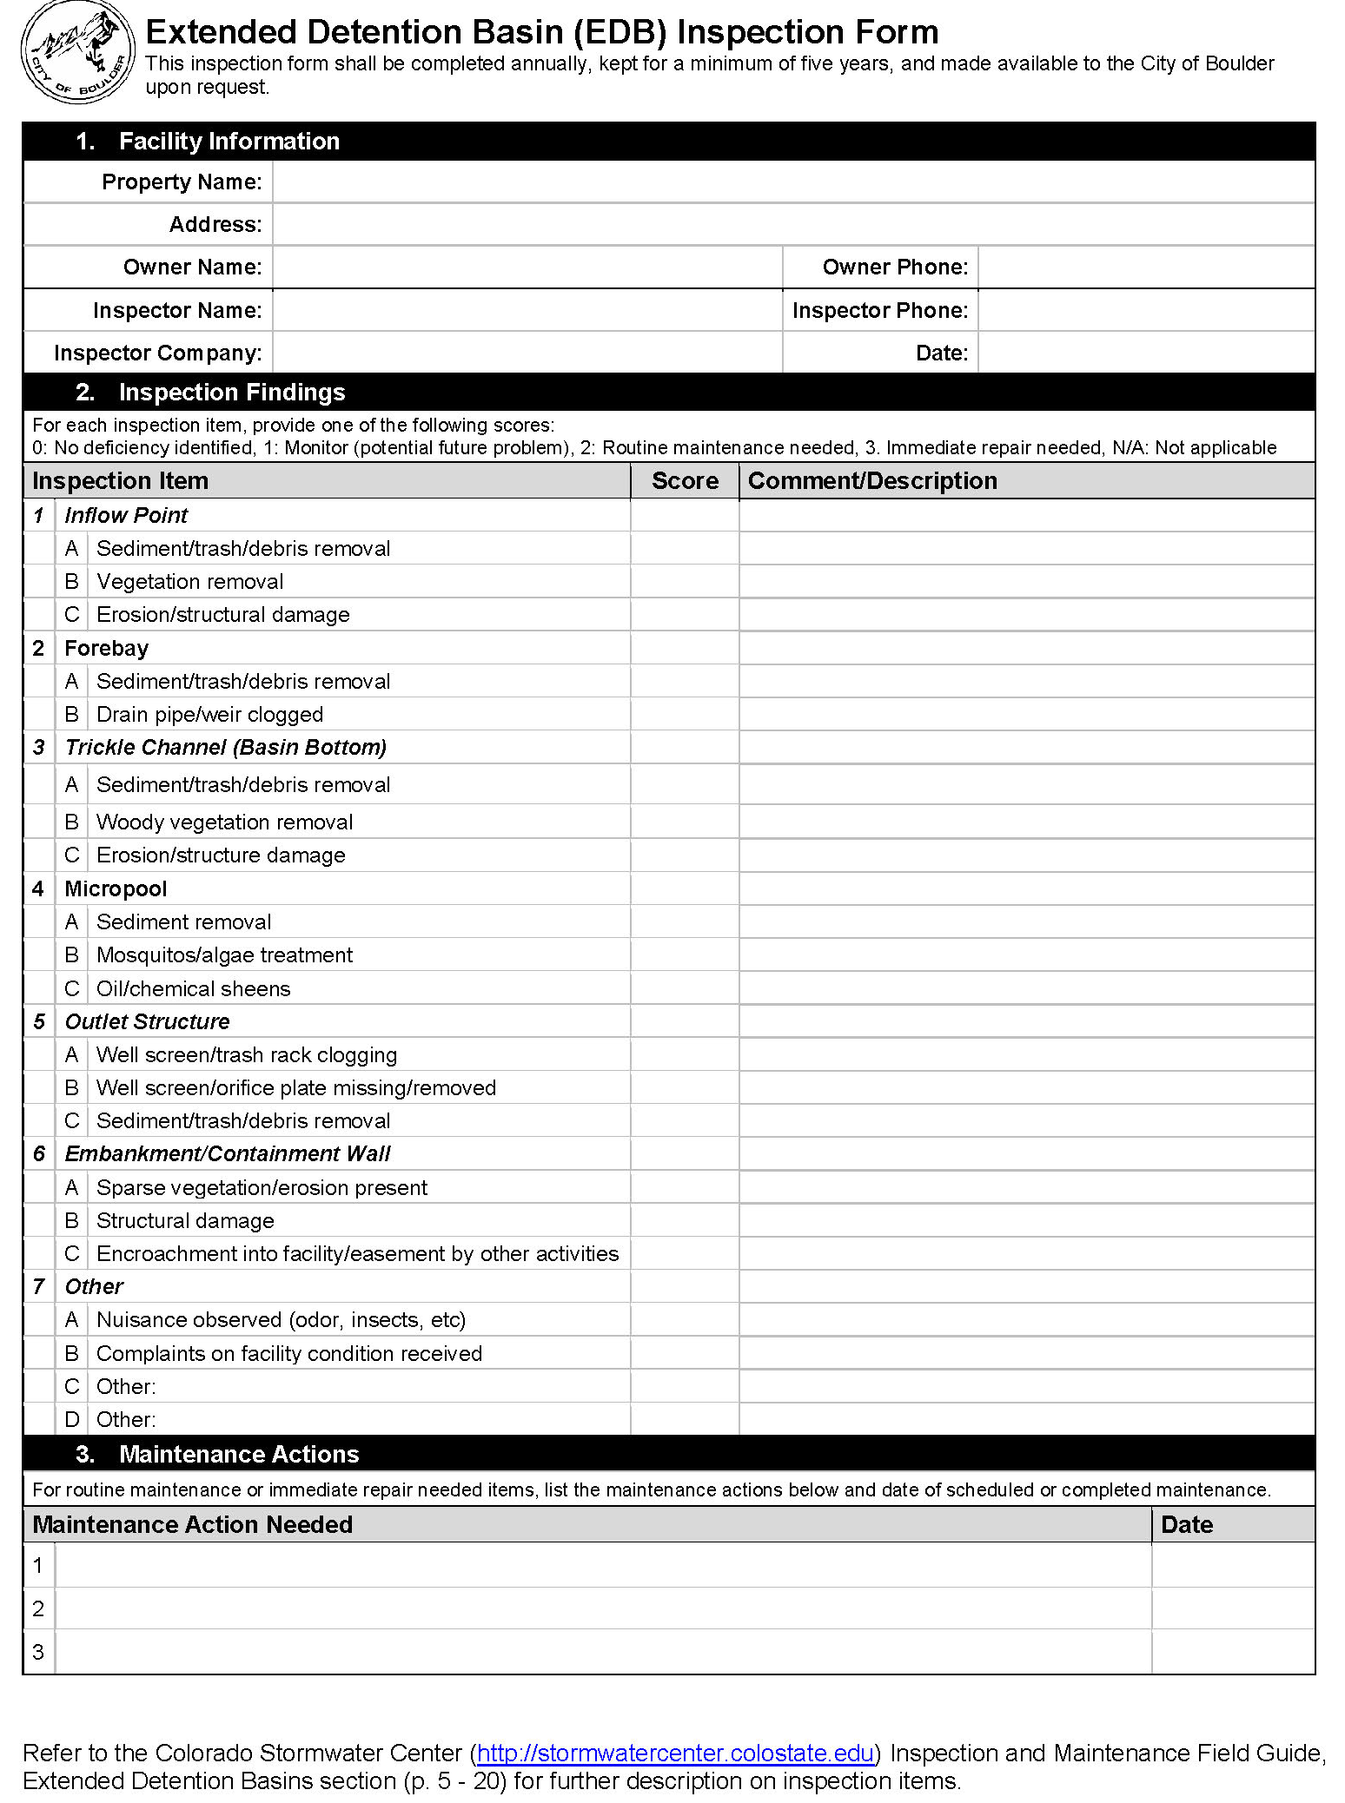

Attachment C. SCM Drawings
Directions to Preparer: Attach construction drawings that are specific to the onsite stormwater control measures. The purpose of these drawings is to depict the components of the facility such that inspection and maintenance staff can locate facility components. It is recommended that this includes a plan layout and detail drawings specific to the SCM facility. Do not include construction drawings unrelated to stormwater components.

