**2020 City of Boulder Energy Conservation Code**

Frequently Asked Questions (FAQs)

1. When does the 2020 energy code take effect? My project is in for Site Review now, but we won’t be permitting until Fall 2020. What code should we be designing to? The effective date for the new code is July 1, 2020. A copy of the code can be downloaded [here](https://www-static.bouldercolorado.gov/docs/2020_City_of_Boulder_Energy_Code_1st_ptg-1-202005051459.pdf?_ga=2.175912098.1419754654.1588603109-1317909585.1579005008). Additional information can be found at [www.BoulderEnergyCode.com](http://www.BoulderEnergyCode.com), including documentation requirements and updated Checklists that are required at the time of permit application.

Applications for projects designed to the 2012 ICC Codes and the 2017 City of Boulder Energy Conservation Code will be accepted through June 30, 2020. Beginning July 1, 2020, all projects applying for a permit must be designed to meet the 2018 ICC suite of codes and the 2020 City of Boulder Energy Conservation Code. There is no grandfathering for projects in Site Review.

1. We’re hearing that the new 2020 City of Boulder Energy Conservation Code is easier to comply with than the 2017 code.  The new code is more stringent, especially for new construction. New ERI requirements for homes are significantly more stringent, requiring that all new homes greater than 3,000 square feet be net-zero energy homes. For commercial projects new efficiency requirements are definitely more stringent than the 2017 energy code. Projects are required to be 25% better than ASHRAE 90.1-2016.

The requirements are in some cases less stringent for Alterations. To remove barriers to reusing existing buildings and discourage scrape and rebuild projects, the requirements for building renovations were relaxed in both the residential and commercial code.

1. Please provide guidance about combination projects that are both a Level 3 or 4 alteration + addition.  An example would be a pop top that also is remodeling the main level.  Per the compliance path shown below, both additions and Level 3 alterations require the project to improve the home by 30%. If it’s a Level 4 alteration and addition, the project would need to meet the new construction ERI targets + 10% (10% less stringent than the new construction requirements).

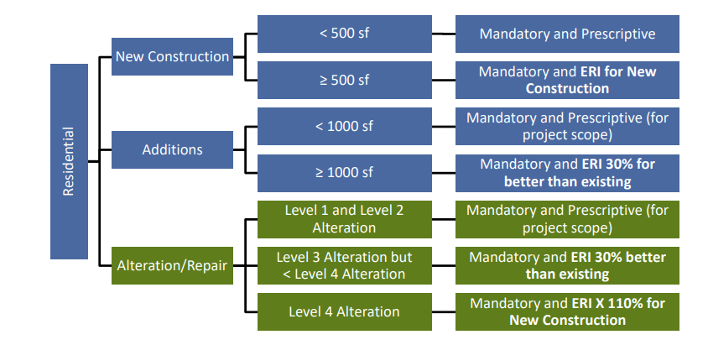

1. It is not clear when R103.2.1 Building thermal envelope depiction applies to alteration projects. Level 1 & 2 alterations are typically only plan view submittals and I assume the depiction would generally be shown in a building section, thoughts? R103.2.1 mainly applies to Level 3 & 4 Alterations. Most Level 1 & 2 Alterations will not need to provide this information. However, if the scope involves significantly reconfiguring the building envelope, plan reviewers may ask for this kind of section. For a basic kitchen remodel, this would not be required – just as an example. A project that installs a new HVAC system may require it to clarify if duct leakage testing is required.
2. For a residential alteration project, what documentation materials are required to demonstrate compliance with a Level 1, 2, 3 or 4 Alteration? The submittal requirements for alterations are very similar to the 2017 energy code requirements, but will depend on the Level of Alteration. Refer the diagram and definitions below. For projects that are Level 1 or Level 2 alterations, completed residential Mandatory and residential Prescriptive checklists must be submitted. These can be found [here](https://bouldercolorado.gov/plan-develop/energy-conservation-codes). The energy code only applies to the scope of work for the Level 1 & 2 alterations. For Level 3 & 4 alterations, two ERI reports will need to be submitted. One showing the ERI of the existing home, prior to renovations, and another showing that the proposed alteration achieves the ERI required by code. Level 3 & 4 alterations also must complete and submit the Mandatory residential checklist as well. This checklist confirms that all the mandatory code provisions have been met.



1. What are the new Deconstruction Waste requirements? Is a deposit required? All demolition and deconstruction projects – residential and commercial – involving removal of more than 50% of exterior walls are required to submit a Deconstruction Plan that identifies how the project will divert from the landfill 75% of the project’s waste by weight. This material must be reused, donated, or recycled. Projects will be required to put a refundable deposit down equivalent to $1/sf (minimum of $1,500). Projects will have 30 days to submit a final report verifying actual diversion achieved, at which point the deposit will be refunded by the city.
2. Can you help clarify the difference between a Level 3 vs Level 4 alteration?  The written definitions are somewhat vague.  In particular with the Level 4 definition there is an "and" in the statement which implies that ALL items must be being addressed to constitute a level 4 alteration.  When writing the definition for a Level 4 alteration, staff was attempting to define a gut renovation. The Level 4 requirements are very tough to meet and are only intended to be triggered if the project is completely replacing mechanical, lighting, insulation, windows, and air barriers. Otherwise, the project shall be considered a Level 3 alteration.
3. The definition of "substantial structural alteration" is very confusing. Calculating the 30% of floor area affected by a gravity load-carrying structural element being altered is likely going to require a structural engineer to make that assessment. Do I need to hire a structural engineer? Concerning the question about whether an engineer would be required to determine if Level 4 alteration criteria have been met, it depends on how complicated the building and alterations are. The International Building Code Section 107.1 provides latitude to not require involvement of a design professional when code compliance can be determined without the involvement of a design professional. So if a project appears to be well below the Level 4 alteration criteria, then having a structural engineer determine the percentage of structure altered would not be necessary. However, if the project appears substantial, the city would require that a design professional demonstrate through supporting calculations that the work proposed is below the threshold of Level 4 alteration.
4. I’m building a detached ADU that’s greater than 500 square feet, but it doesn’t have a kitchen, bath, or dedicated bedroom. Do I still need to achieve an ERI to comply with the energy code? Although an ERI score can be obtained for any size home regardless how small, the home must have a kitchen, bath, and dedicated bedroom to be modeled under the RESNET Standard. Projects without these elements are unique and will be exempt from the ERI requirement. Instead these projects will need to meet the mandatory and prescriptive provisions in the 2020 City of Boulder Energy Conservation Code to comply. Instead of submitting an ERI report they’ll need to submit the mandatory and prescriptive checklists.
5. For a Level 3 Alteration, where you need to show a HERS score before, and beat that by 30%, does the HERS score need to be an actual 'Final' score, registered with the RESNET registry, or just a 'Prelim' HERS score? No, the “before” HERS score does not need to be registered with RESNET.
6. How should off-site solar on residential projects be handled in the ERI report? For projects pursuing off-site solar to comply with an ERI code requirement, the project shall first demonstrate that on-site solar is technically infeasible per R406.4.2 of the 2020 City of Boulder Energy Conservation Code. Provided off-site solar is allowable, two HERS reports shall be submitted at the time of building permit. One report without the additional PV showing how the home would perform before solar is applied, and a 2nd report showing the PV equivalent to the amount contracted with the solar garden. The 2nd report would have a significantly lower HERS score that should meet the code requirements for the home. Note, to comply with RESNET’s quality assurance process, it will be the 1st report showing no solar on site which is confirmed and registered with RESNET.
7. Our project is replacing the lighting system for an entire building, but not reconfiguring more than 10% of the space. Is this a Level 2 or 3 Alteration? A common concern raised with some renovation projects is that Level 2 Alteration work needs to be limited to 50% of the building area; otherwise, the project will be classified as a Level 3 Alteration and the building will need to be brought up to full compliance with the current code. It is important to know the following three classifications/definitions from the 2018 International Existing Building Code (IEBC):

* A level 2 Alteration includes the reconfiguration of space, the addition or elimination of any door or window, the reconfiguration or extension of any system, or the installation of any additional equipment.
* Level 3 Alterations apply where the work area exceeds 50 percent of the aggregate building area.
* A “work area” is defined as the portion or portions of a building consisting of all reconfigured spaces as indicated on the construction documents. Work areas exclude other portions of the building where incidental work entailed by the intended work must be performed and portions of the building where work not initially intended by the owner is specifically required by the IEBC code.

To have a level 3 Alteration, the project needs to have a work area (consisting of reconfigured spaces) that exceeds 50% of the aggregate building area. A project could have level 2 Alterations in 100% of the building area and not trigger a Level 3 Alteration. Your project is an example of this where the installation of a new lighting system throughout the building without reconfiguring more than 50% of the space does not trigger Level 3 Alteration requirements.